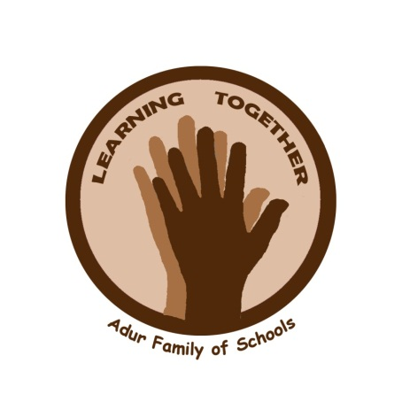



HOLMBUSH PRIMARY SCHOOL

Uniform Policy

Introduction from the Adur Family of Schools

The aim of this policy is to set out the requirements for school uniform. Holmbush Primary School has a school uniform policy determined by the Governors and it is expected that all pupils will comply with it.

A school uniform looks smart, and clearly identifies the school, encourages a sense of belonging and helps good behaviour; pupils should wear the uniform with pride. This policy allows all pupils to feel included and reduces any inequalities or pressures of fashion.

We expect that, in choosing our school, you will give us your full support.

The above introduction has been formulated as a shared statement by all schools within the Adur Family of Schools.

Shoeless Classrooms
Holmbush Primary School operates Shoeless Classrooms in order to provide a high quality environment which is the most conducive to learning. If parents wish for their children to wear slippers or thick socks they may as long as they are in plain colours with no moving or flashing parts.

Our Requirements:
Girls
Black or grey skirt, trousers, shorts or pinafore dress
White polo shirt or blouse
Bottle green sweatshirt or cardigan
Black, grey, white or bottle green socks or tights
Green and white checked or striped summer dress
Dark coloured, flat outdoor shoes or boots

Boys
Black or grey trousers or shorts
White polo shirt or shirt
Bottle green sweatshirt
Black, grey or white socks
Dark coloured, flat outdoor shoes or boots

P.E Indoor/Outdoor kit:
Bottle green or black shorts
Dark coloured tracksuit bottoms (non branded)
White T-shirt
Coloured house team T-shirt
Black Plimsolls or Non-branded training shoes – not fashion shoes
Bare feet for gym or dance, boots may be worn for football or rugby
No jewellery can be worn for PE. Long hair must be tied back.
Swimming – swimming costume and swimming hat

Jewellery – in the interests of safety only plain stud earrings (neutral colours) and a small watch may be worn. There should be no make-up, nail varnish, temporary tattoos or hair colours. Hair accessories should be in school uniform colours.

No toys or electrical equipment of any kind should be in school. Mobile phones need to be switched off and left in children’s bags. The school takes no responsibility for the children’s possessions.

In addition…
- No outside garments to be worn in building (coats and hats)
- Uniform to be worn properly (shirts tucked in, collars down, trousers worn at waist level etc.)

Children not complying can expect
- To be given spare uniform to change into immediately
- To have a letter sent home
- To have items confiscated for the day
- To be asked to remove nail varnish and make up

Non-Uniform Days
On non-uniform days we kindly ask that parents do not send their children into school in night garments (e.g. onesies) and that they wear adequate clothing for playing outside at break times.

The senior leadership team will meet with parents where children are consistently not in the correct uniform.

The school office sells the following items: drinks bottles, book bags, PE bags, PE shorts and T-shirts, school sweatshirts and cardigans.

